**Satriyo Yudha**

**NIM:233140707111082**

**Modul 5**

**Input code Modul 5 CV HTML**

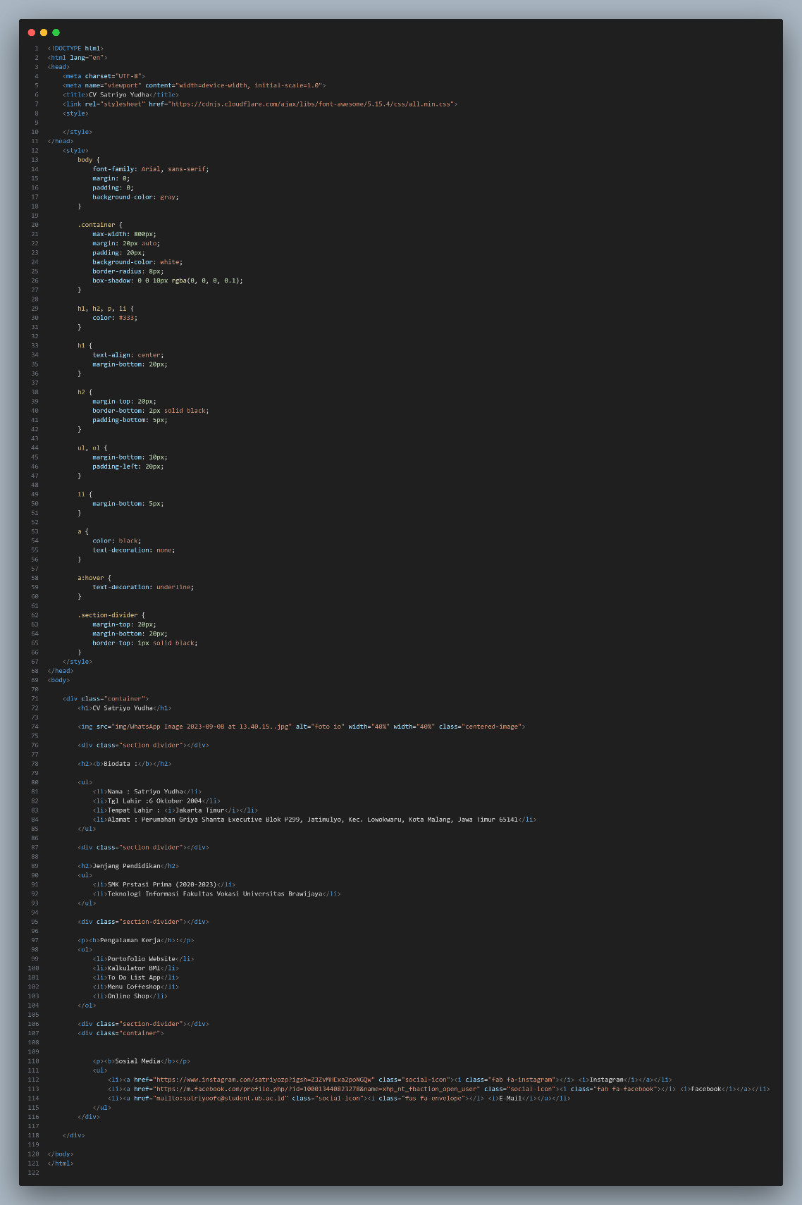

**Input code Modul 5 CV CSS**

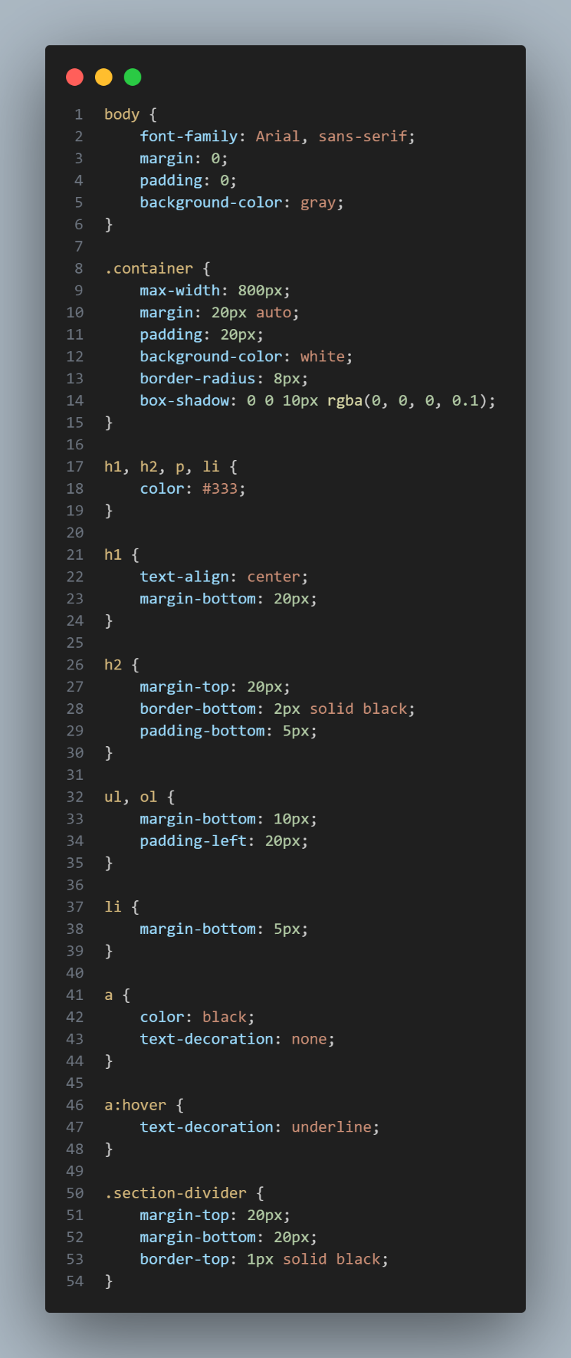

**Input code Modul 5 UMKM HTML**

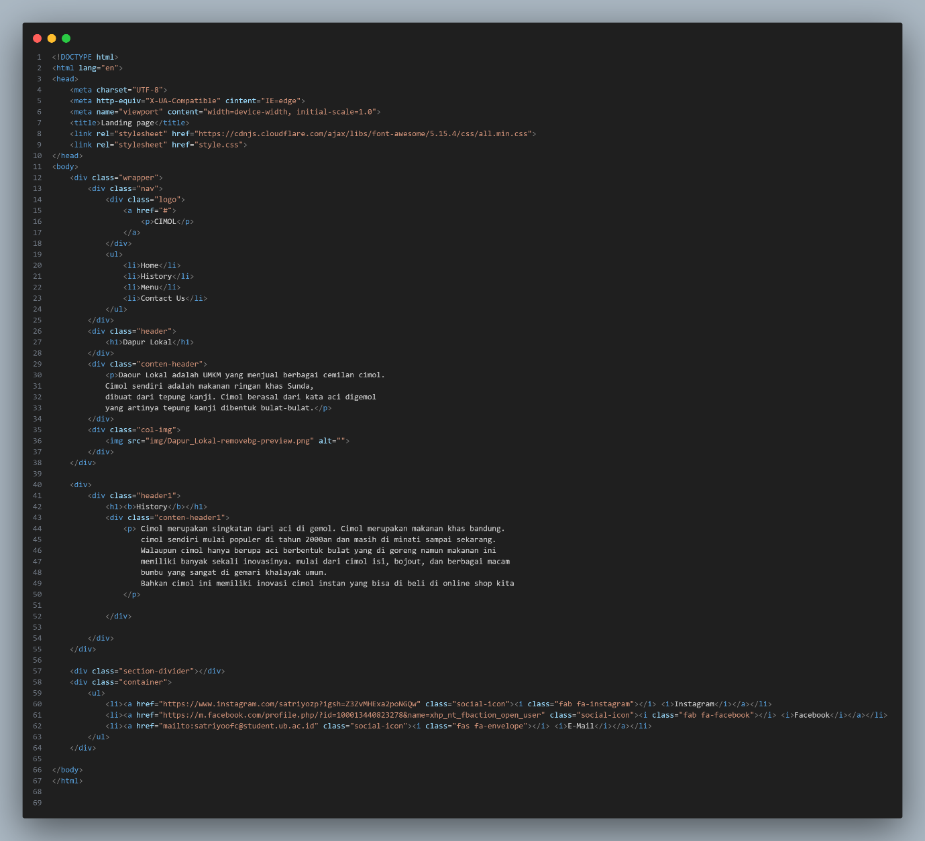

**Input code Modul 5 UMKM CSS**

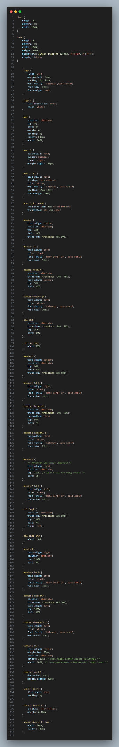

**Output code Modul 5 CV**

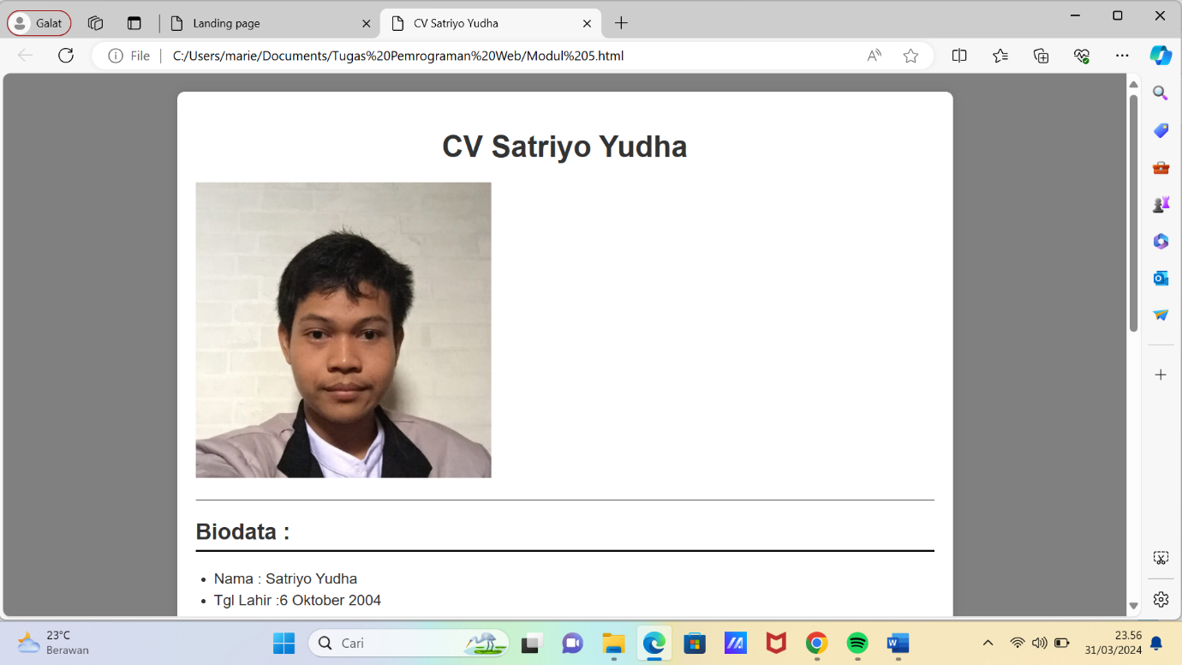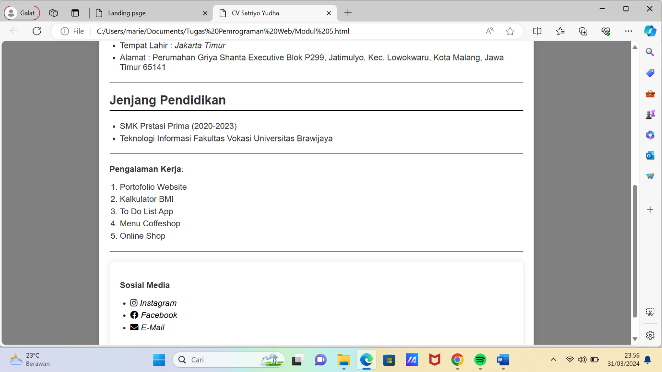

**Output code Modul 5 UMKM**

